  

MERN STACK- ONLINE COMPLAINT REGISTRATION AND MANAGEMENT SYSTEM

**In partial fulfillment for the award of the degree Of**

BACHELOR OF ENGINEERING

**Department of Computer Science & Engineering**

**Submitted by**

**ARUNKUMAR.CH.T - 110521104005**

**ASMITHA.E - 110521104057**

**BHAKKIYA LAKSHMI P - 110521104058**

**DEEPIKA.G - 110521104301**

  

BONAFIDE CERTIFICATE

Certified that this Project on “**MERN STACK - ONLINE COMPLAINT REGISTRATION AND MANAGEMENT SYSTEM”,** is a Bonafide record of the work done by BHAKKIYA LAKSHMI P - 110521104007.

In The Department of **Computer Science & Engineering** , Anna University, Chennai.

**Internal Guide Head of the Department**

**Internal Examiner External Examiner**

**ABSTRACT**

Complaint Management System provides an online way of solving the problems faced by the public by saving time and eradicate corruption. The objective of the complaints management system is to make complaints easier to coordinate, monitor, track and resolve, and to provide company with an effective tool to identify and target problem areas, monitor complaints handling performance and make business improvements.Complaint Management is a management technique for assessing, analyzing and responding to customer complaints. Complaints management software is used to record resolve and respond to customer complaints, requests as well as facilitate any other feedback. The main purpose of this project is to help the public in knowing their place details and getting their problems solved in online without going to the officer regularly until the problem is solved. By this system the public can save his time and eradicate corruption in government offices. In the proposed system the citizen need not go to the government office for getting his problem solved. He can get his problem solved by posting his problem in this proposed system and he can suggest a possible solution to the problems posted on the system. He can even get the information of the funds and other details of his place in detail through this system.

|  |  |  |
| --- | --- | --- |
| **Chapter No** | **Chapter Title** | **Page No** |
| **1** | **COMPANY PROFILE** | **1-3** |

* 1. History of the Organization 1
     1. Objectives 1
     2. Operations of the Organization 2
  2. Major Milestones 2
  3. Structure of the Organization 3
  4. Services Offered 3
  5. Specific Functionalities of the Department 4

|  |  |  |
| --- | --- | --- |
| **2** | **ABOUT THE DEPARTMENT** | 4-7 |

* 1. Process Adopted 4
  2. Testing 5
  3. Structure of Department 6
  4. Roles and Responsibilities of Individuals 7

|  |  |  |
| --- | --- | --- |
| **3** | **REFLECTION NOTES** | 9-25 |

3.1 Experience 9

3.1 Technical Outcomes 10

3.1.1 System Requirement Specification 11

3.1 System Analysis and Design 11

1. Existing System 11
2. Disadvantages of the Existing System 11
3. Proposed System 12
4. Advantages of the Proposed System 12

3.2 System Architecture 12

1. Data Flow Diagram 12
2. UML Diagram 13
3. USE CASE Diagram 13
4. Sequence Diagram 14
5. Activity Diagram 15

3.3 Implementation 15

1. Modules 18

3.4 Screen Shots 23

**COMPANY PROFILE**

* 1. **History of the Organization**
     + Company name: Bharat Electronics Limited
     + Type: Incorporated
     + Industry: Manufacture, Electronics and Defence.
     + Founded on: 1954, Bengaluru
     + Headquarter: 2HW6+2P9,Outer Ring Rd, Jalahalli, Bengaluru, Karnataka 560013
     1. **Objectives**
        + To be a customer focused company providing state-of-the-art products & solutions at competitive prices, meeting the demands of quality, delivery & service.
        + To generate internal resources for profitable growth.
        + To attain technological leadership in defence electronics through in-house R&D, partnership with defence/research laboratories & academic institutions.
        + To give thrust to exports.
        + To create a facilitating environment for people to realise their full potential through continuous learning & team work.
        + To give value for money to customers & create wealth for shareholders.
        + To constantly benchmark company's performance with best-in-class internationally.
        + To raise marketing abilities to global standards.
        + To strive for self-reliance through indigenisation.
     2. **Operation of the Organization**

BEL is a multi-product, multi-technology, multi-Unit conglomerate boasting of over 350 products in the areas of Radars, Missile Systems, Military Communications, Naval Systems, Electronic Warfare & Avionics, C4I Systems, Electro Optics, Tank Electronics & Gun/Weapon System Upgrades, Solar Photovoltaic Systems, Electronic Components and civilian products.

The gamut of products includes small components costing a few rupees to huge systems costing crores of rupees. With its expertise developed over the years, the company also provides turnkey systems solutions. While Defence continues to contribute to nearly 80 to 85% of its revenue, BEL has touched a chord with the common man through civilian products like solar traffic signals and Electronic Voting Machines (EVMs).

BEL’s reliable and tamper-proof EVMs have redefined voting in India, facilitating free and fair elections. BEL’s customers include the Army, Navy, Air Force, Paramilitary, Coast Guard, Police, Doordarshan, All India Radio, Department of Telecommunications and consumers of professional electronic components.

* 1. **Major Milestones**

BEL has been doing it bit to promote the Government’s Make in India initiative. BEL is focusing more on core areas and R&D, even as all non-core areas are being outsourced to Indian industries including MSMEs. A long-term Outsourcing & Indigenisation Policy has been released. Nodal officers for outsourcing and vendor development have been nominated. Annually, around 800 new indigenous vendors are added.

New Business Initiatives taken include laying the foundation stone for a new Defence Systems Integration Complex at Anantapur district to expand the Missile Systems business and another state-of-the-art Advanced Night Vision Products Factory at Nimmaluru village in Krishna District of Andhra Pradesh.

Some of the significant orders executed during 2015-16 include supply of Akash Weapon System (Indian Army & Indian Air Force), 3-D Tactical Control Radar (Army), Schilka Upgrade (Army), Passive Night Vision Devices (Army), Low Level Light Weight Radar (Air Force), Fire Control System (Navy), Integrated Sonar Suite (Navy), Ship Data Network (Navy), New Generation Sonars (Navy) and L Band Surveillance Radar for Export (Myanmar).

* 1. **Structure of the Organization**

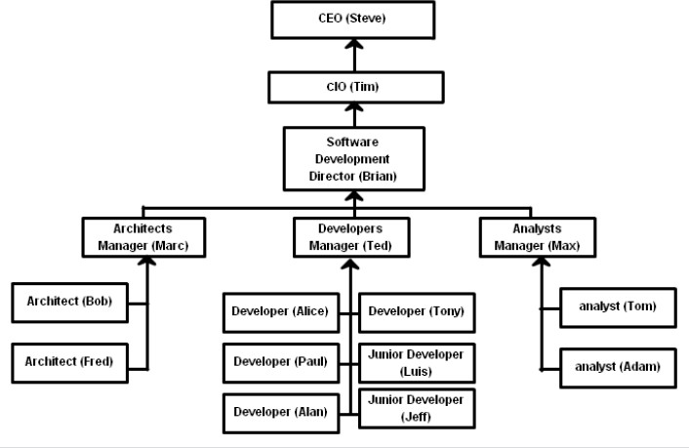

**Figure 1.1** Organizational Structure

* 1. **Services Offered**

Services offered by Bharat Electronics Limited are listed below:-

* + - Electronic voting machines.
    - Voter-verified paper audit trail.
    - Traffic signals.
    - BEL Weapon Locating Radar.
    - BEL Battle Field Surveillance Radar.
    - Telecommunications.
    - Sound and vision broadcasting.
    - Opto-electronics.
    - Information technology.

**ABOUT THE DEPARTMENT**

* 1. **Specific Functionalities of the Department**

Bharat Electronics Limited (BEL) is an Indian Government-owned aerospace and defence electronics company**.** The IT Department of Bharat Electronics Limited has evolved and transformed into a highly productive, result oriented department. BEL manufactures a wide range of products in areas like Defence Communications, Radars, Telecommunications, SATCOM, Sound and Vision Broadcasting, Opto & medical Electronics and Electronic Components. Services offered by BEL include Contract Manufacturing, Telecom Consultancy and Semiconductor Device packaging.

* 1. **Process Adopted**

SDLC is a process followed for a software project, within a software organization. It consists of a detailed plan describing how to develop, maintain, replace and alter or enhance specific software. The life cycle defines a methodology for improving the quality of software and the overall development process. A SDLC process as following mentioned steps:

* + - Planning
    - Defining
    - Designing
    - Building
    - Testing
    - Deployment
  1. **Testing**

The various testing techniques used by the department can be summarized as follows:

1. Functionality Testing of a Website: it is a process that includes several testing parameters like user interface, APIs, database testing, security testing, client and server testing and basic website functionalities. Functional testing is very convenient and it allows users to perform both manual and automated testing. It is performed to test the functionalities of each feature on the website.
2. Usability Testing: This type of testing includes testing the site navigations and contents of the website.
3. Interface Testing: Three areas to be tested here are Application,Web and Database Server.
4. Database Testing: Database is one critical component of your web application and stress must be laid to test it thoroughly Testing activities will include Test if any errors are shown while executing queries, Data Integrity is maintained while creating, updating or deleting data in database, Check response time of queries and fine tune them if necessary, Test data retrieved from your database is shown accurately in your web application.
5. Compatibility testing: Compatibility tests ensures that your web application displays correctly across different devices. This would include-Browser Compatibility Test: Same website in different browsers will display differently. You need to test if your web application is being displayed correctly across browsers, JavaScript, AJAX and authentication is working fine.
6. Pipeline testing: After compatibility testing it is the time to test all the micro-services in pipeline together to check their compatibility and message passing. Thus all the services/functionalities are kept in pipeline and tested together. Afterwards whole pipeline is pushed in the deployment server.
   1. **Structure of the Department**

The structure of the organisation is descripted in the following figure:

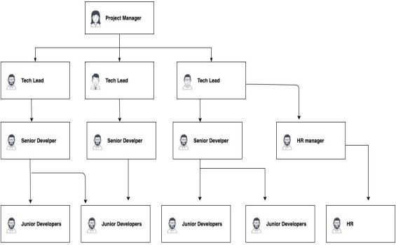

**Figure 2.2:** Department Structure

* 1. **Roles and Responsibilities of Individuals**

The different roles and responsibilities of individuals are:

1. Project Manager: Project Managers play the lead role in planning, executing, monitoring, controlling, and closing projects. They're expected to deliver a project on time, within the budget, and brief while keeping everyone in the know and happy.
2. Tech Leads: Technical Lead as the name states is solely responsible for leading a development team. The is not easy. They have to lead a team. Technical Lead is the one who actually creates a technical vision in order to turn it into reality with the help of the team.
3. HR Manager: The Human Resource Manager will lead and direct the routine functions of the Human Resources (HR) department including hiring and interviewing staff, administering pay, benefits, and leave, and enforcing company policies and practices.
4. Senior Developer: Develops software solutions by studying information needs, conferring with users, studying systems flow, data usage, and work processes; investigating problem areas; and following the software development lifecycle. A senior developer may manage a team of developers and will be expected to encourage creativity and efficiency throughout complex digital projects. Due to the pressurised nature of the role, a robust and organised approach to the work is needed to produce the best solutions.
5. Junior Developer: Junior Software Developers are entry-level software developers that assist the development team with all aspects of software design and coding. Their primary role is to learn the codebase, attend design meetings, write basic code, fix bugs, and assist the Development Manager in all design-related tasks.

**TASK PERFORMED**

Worked as a App Developer, I was responsible for the completion of the following tasks in the company:

1. I was responsible for implementing visual elements that users see and interact with in a mobile application.
2. To develop new user-facing features and build reusable code and libraries for future use.
3. To ensure the technical feasibility of UI/UX designs and to optimize application for maximum speed and scalability.
4. To assure that all user input is validated before submitting to back-end and collaborate with other team members and stakeholders.
5. Produce fully functional mobile applications writing clean code
6. Gather specific requirements and suggest solutions
7. Write unit and UI tests to identify malfunctions
8. Troubleshoot and debug to optimize performance
9. Design interfaces to improve user experience

**REFLECTION NOTES**

* 1. **Experience**

Although internship vary greatly from one organization to the next, the term traditionally refers to real-world work experiences in which students fulfil short-term positions within a company or organization in order to gain hands-on experience and develop careerspecific skills. Sponsoring agencies generally work with the student to meet specific learning goals and provide special mentoring or networking opportunities. In exchange, the intern helps the employer in meeting overall work goals for the company.

* + - Communication of the thoughts to the employees, ideas, and information in writing through e-mails and letters.
    - The skill of listening to the higher authority and acting according to the situation at the workplace.
    - The effective ways of communicating with the co-workers or employees at the company, raising the level of self-confidence.
    - The skill of making the right decision for a given problem that occurs while on work in the company.
    - Problem solving is a major requirement for any engineer and the internship provide the flow of thoughts to solve a problem in different and effective ways.
    - The internship helped in socializing with new people at workplace and learning to convey our thoughts in the right manner.
    - Along with all the skills we also gained hands on experience with technical projects worked upon during the course of internship.
  1. **Technical Outcomes**

The outcomes of attending an internship program as per the curriculum are not only in terms of technical knowledge, but also learnt many norms of a corporate office. The experience of working in an office will surely be an add while working for an organization after graduation. The outcomes can be summed up as follows:

* + - The communication of ideas and thoughts regarding a problem with the employees of the company gave interns high confidence and boosted up the decision making capabilities.
    - As an engineer it is critical to have problem solving ability and this skill was accomplished by doing research and working on various technologies that were being used in the company during the internship period.
    - Web Development being one of the top domains in the current scenario, working on such a domain specifically to produce an outcome to the company helped us enhance our knowledge base in this area.
    - Working with multiple projects under the guidance of employees at work gave us hands on experience to solve and work with common errors and sometimes even complex ones.
    - By gaining exposure to projects enabled ourselves to think in critical manner and draw out some advantages and disadvantages of the works that did at the company during the internship.
    - The constant communication with the employees gave an experience with the actual work environment which is quite different when compared the exposure at the colleges and classrooms.
    - The spark to learn new technologies and enhance our skillset was lit by watching the various work flow that happened in the organization. Learning is never ending process and experiencing advanced technologies to give a product that can help society to solve minute problems is the job of an engineer.
    1. **System Requirement Specification**

Functional Requirements:-

* + - * Dart 2.15.1 or Higher
      * Git/Github
      * MongoDB 5.0
      * Code Editor:- Flutter, Android Studio, Visual Studio.

Non-Functional Requirements:-

* + - * Operating System:- Windows 7 or later(64-bit).
      * Disk Space:- 128 GB high speed storage (M.2 SSDs)

# System Analysis and Design

## Existing System

The Organization had been using a web application for receiving complaints from the customers. This web Application makes use of MySQL as it’s database for storing complaints and then reverting back to those complaints.

## Disadvantages of the Existing System

* Development time and cost is much higher for a web application.
* Dependence on web browser.
* Portability.
* Unattractive User Interface.

## Proposed System

“Complaint Management Mobile Application” is the proposed system which improves the user experience and allows the user to express his/her dissatisfaction about the company or their services easily by their mobile phone.

This Mobile application helps to reduce the time and procedure for complaint handling, increase the channel for filing the complaint, and increase the channel for progress reporting and tracking the status of the complaint

## Advantages of the Proposed System

* + - * Enhanced user experience.
      * Ease to access.
      * Productivity improvement and cost reduction.
      * Easy to maintain.

# System Architecture

* + 1. **Data Flow Diagram**

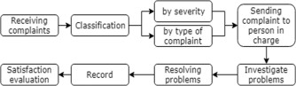

**Figure 4.1:** Data Flow Diagram

* + - 1. **Sequence Diagram**

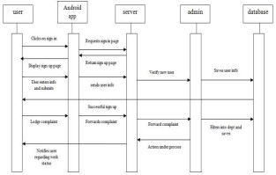

**Figure 4.3:** Sequence Diagram

A sequence diagram simply depicts interaction between objects in a sequential order i.e. the order in which these interactions take place. We can also use the terms event diagrams or event scenarios to refer to a sequence diagram.

* + - 1. **Activity Diagram**

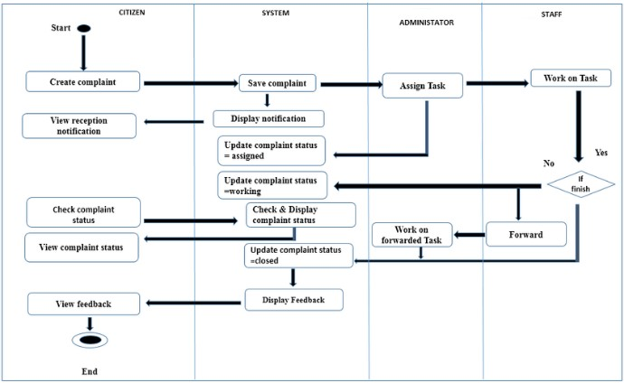

**Figure 4.4:** Activity Diagram

* 1. **Implementation**

**Login Page**

import 'package:flutter/material.dart'; void main() => runApp(const MyApp());

class MyApp extends StatelessWidget {

const MyApp({Key? key}) : super(key: key); static const String _title = 'Sample App';

@override

Widget build(BuildContext context) { return MaterialApp(

title: _title, home: Scaffold(

appBar: AppBar(title: const Text(_title)), body: const MyStatefulWidget(),

),

);

}

}

class MyStatefulWidget extends StatefulWidget {

const MyStatefulWidget({Key? key}) : super(key: key);

@override

State<MyStatefulWidget> createState() => _MyStatefulWidgetState();

}

class _MyStatefulWidgetState extends State<MyStatefulWidget> { TextEditingController nameController = TextEditingController(); TextEditingController passwordController = TextEditingController();

@override

Widget build(BuildContext context) { return Padding(

padding: const EdgeInsets.all(10), child: ListView(

children: <Widget>[ Container(

alignment: Alignment.center, padding: const EdgeInsets.all(10), child: const Text(

'TutorialKart', style: TextStyle(

color: Colors.blue,

fontWeight: FontWeight.w500, fontSize: 30),

)),

Container(

alignment: Alignment.center, padding: const EdgeInsets.all(10), child: const Text(

'Sign in',

style: TextStyle(fontSize: 20),

)),

Container(

padding: const EdgeInsets.all(10), child: TextField(

controller: nameController, decoration: const InputDecoration( border: OutlineInputBorder(), labelText: 'User Name',

),

),

),

Container(

padding: const EdgeInsets.fromLTRB(10, 10, 10, 0), child: TextField(

obscureText: true,

controller: passwordController, decoration: const InputDecoration( border: OutlineInputBorder(), labelText: 'Password',

),

),

),

TextButton( onPressed: () {

//forgot password screen

},

child: const Text('Forgot Password',),

),

Container( height: 50,

padding: const EdgeInsets.fromLTRB(10, 0, 10, 0), child: ElevatedButton(

child: const Text('Login'), onPressed: () { print(nameController.text); print(passwordController.text);

},

)

),

Row(

children: <Widget>[

const Text('Does not have account?'), TextButton(

child: const Text( 'Sign in',

style: TextStyle(fontSize: 20),

),

onPressed: () {

//signup screen

},

)

],

mainAxisAlignment: MainAxisAlignment.center,

),

],

));

}

}

**Complaint Registration Page**

import 'package:flutter/material.dart';

class SignupPage extends StatelessWidget { @override

Widget build(BuildContext context) { return Scaffold( resizeToAvoidBottomInset: false, resizeToAvoidBottomPadding: false, backgroundColor: Colors.white, appBar: AppBar(

elevation: 0,

brightness: Brightness.light, backgroundColor: Colors.white, leading:

IconButton( onPressed: (){ Navigator.pop(context);

},icon:Icon(Icons.arrow_back_ios,size: 20,color: Colors.black,)),

),

body: SafeArea(

child: SingleChildScrollView( child: Container(

height: MediaQuery.of(context).size.height, width: double.infinity,

child: Column(

mainAxisAlignment: MainAxisAlignment.spaceBetween, children: [ Column(

children: [ Column(

mainAxisAlignment: MainAxisAlignment.spaceEvenly, children: [

Text ("Sign up", style: TextStyle( fontSize: 30,

fontWeight: FontWeight.bold,

),),

SizedBox(height: 20,),

Text("Create an Account,Its free",style: TextStyle( fontSize: 15,

color: Colors.grey[700],

),),

SizedBox(height: 30,)

],

),

Padding(

padding: EdgeInsets.symmetric( horizontal: 40

),

child: Column( children: [

makeInput(label: "Email"),

makeInput(label: "Password",obsureText: true), makeInput(label: "Confirm Pasword",obsureText: true)

],

),

),

Padding(

padding: EdgeInsets.symmetric(horizontal: 40), child: Container(

padding: EdgeInsets.only(top: 3,left: 3), decoration: BoxDecoration(

borderRadius: BorderRadius.circular(40), border: Border(

bottom: BorderSide(color: Colors.black), top: BorderSide(color: Colors.black), right: BorderSide(color: Colors.black), left: BorderSide(color: Colors.black)

)

),

child: MaterialButton( minWidth: double.infinity, height:60,

onPressed: (){},

color: Colors.redAccent,

shape: RoundedRectangleBorder( borderRadius: BorderRadius.circular(40)

),

child: Text("Sign Up",style: TextStyle( fontWeight: FontWeight.w600,fontSize: 16,

),),

),

),

),

SizedBox(height: 20,),

Row(

mainAxisAlignment: MainAxisAlignment.center, children: [

Text("Already have an account? "), Text("Login",style: TextStyle(

fontWeight: FontWeight.w600, fontSize: 18

),),

],

)

],

),

],

),

),

),

),

);

}

}

Widget makeInput({label,obsureText = false}){ return Column(

crossAxisAlignment: CrossAxisAlignment.start, children: [

Text(label,style:TextStyle( fontSize: 15,

fontWeight: FontWeight.w400, color: Colors.black87

),),

SizedBox(height: 5,), TextField(

obscureText: obsureText, decoration: InputDecoration(

contentPadding: EdgeInsets.symmetric(vertical: 0,horizontal: 10), enabledBorder: OutlineInputBorder(

borderSide: BorderSide( color: Colors.grey[400],

),

),

border: OutlineInputBorder(

borderSide: BorderSide(color: Colors.grey[400])

),

),

),

SizedBox(height: 30,)

],

);

}

# Screen Shots

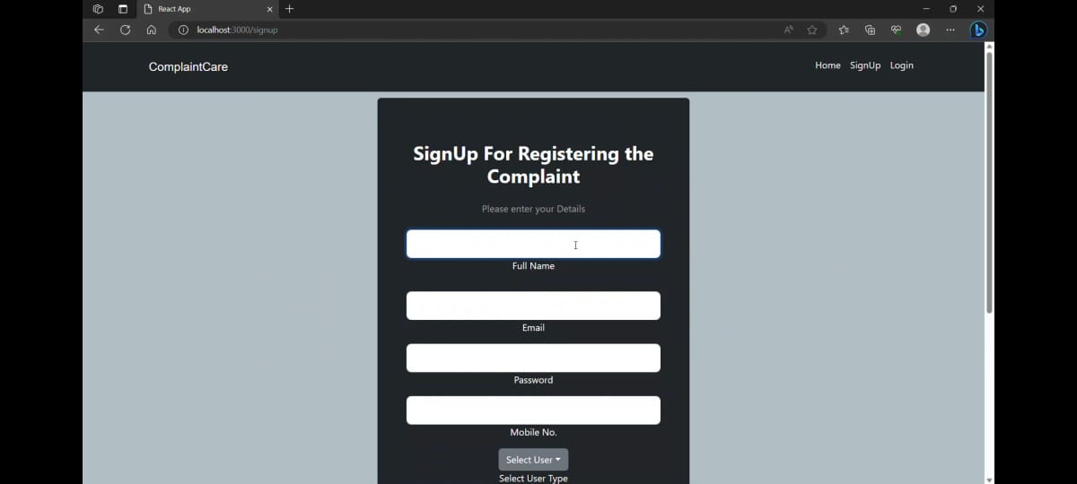

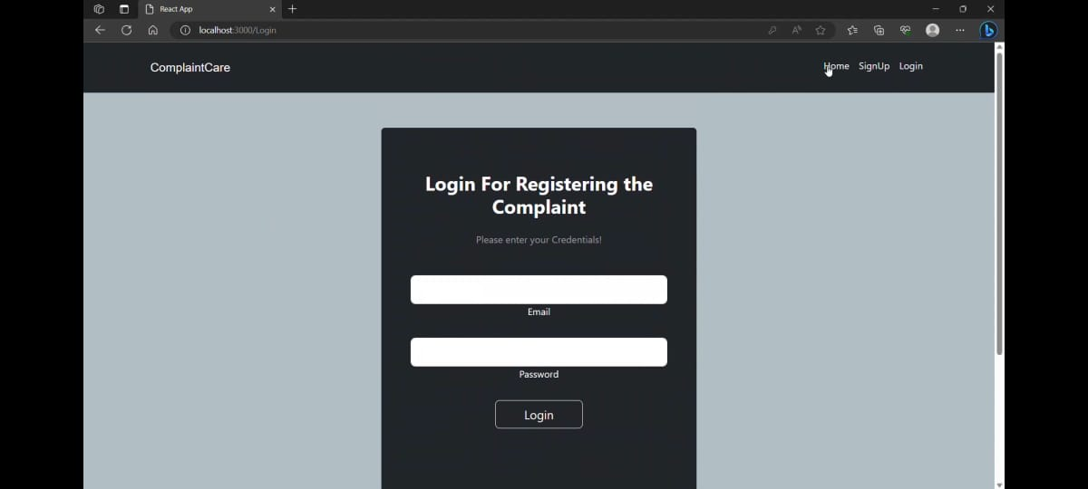

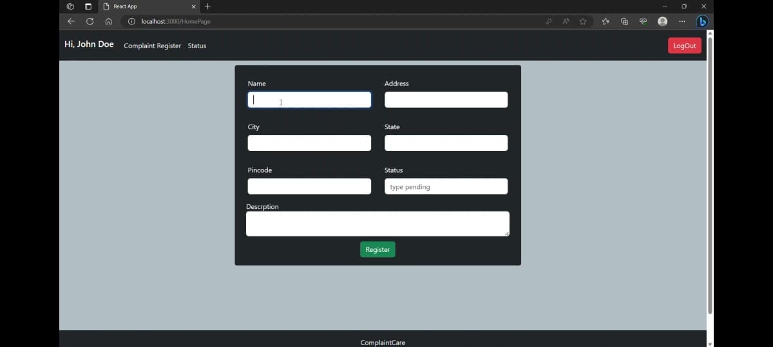

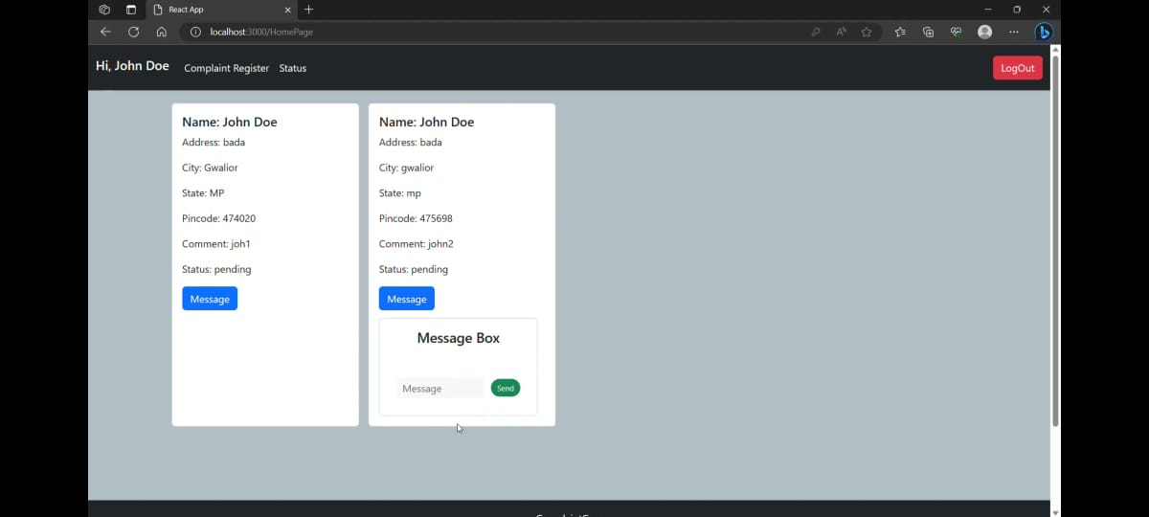

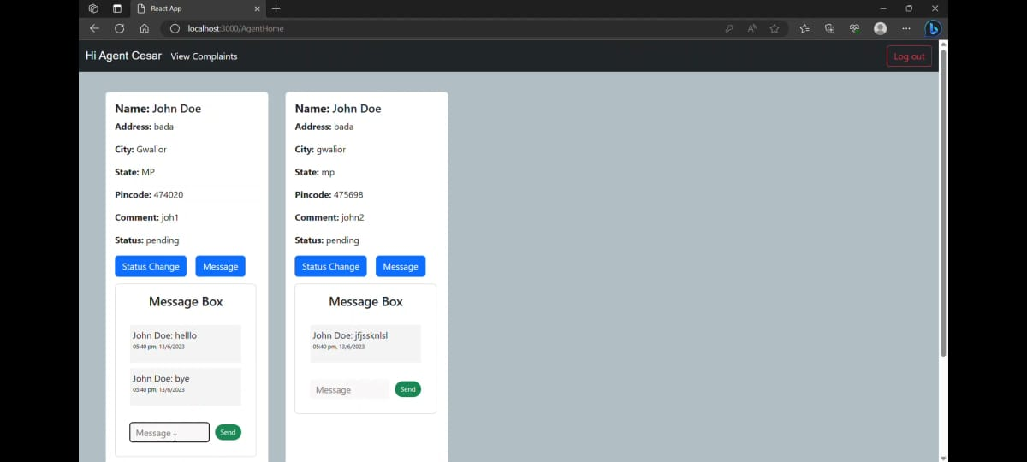



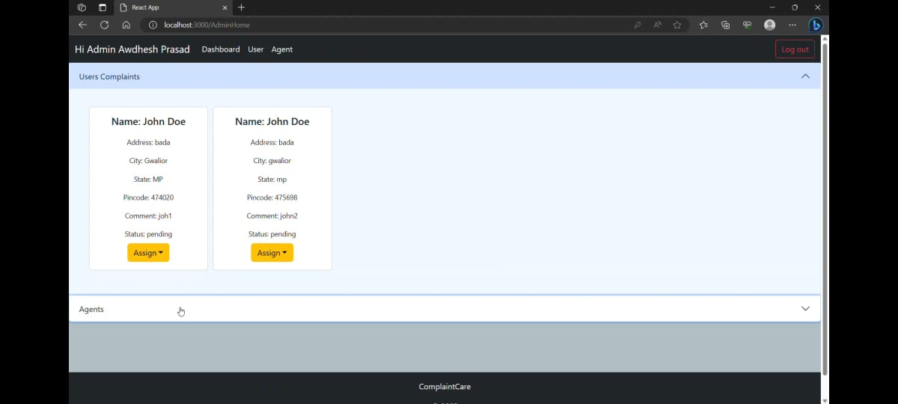

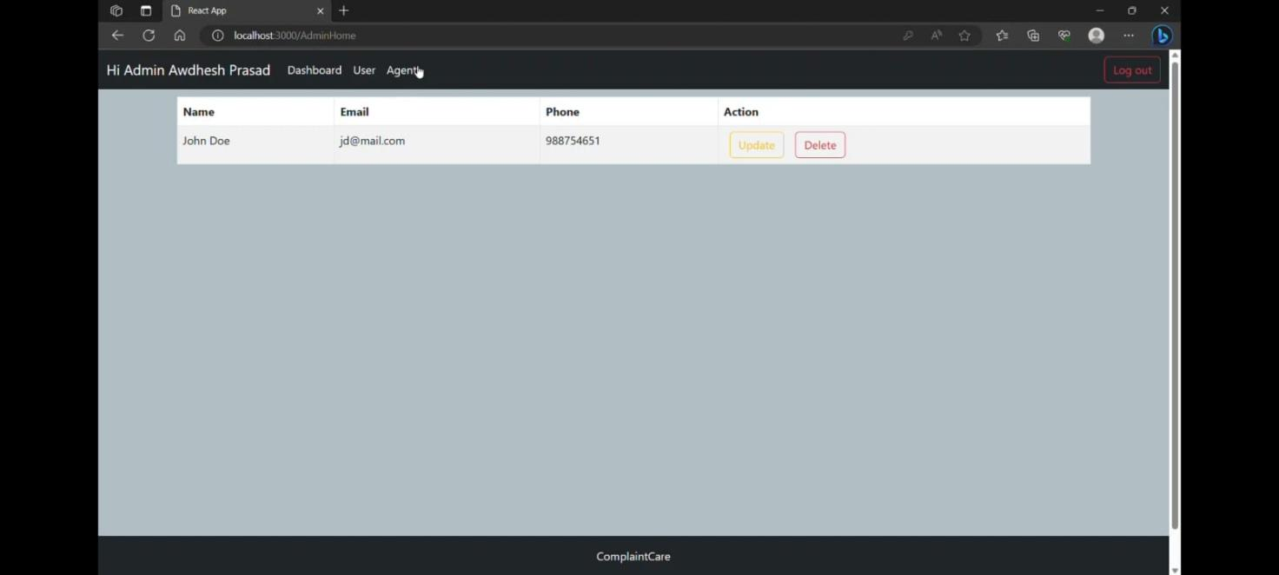

**CONCLUSION**

Complaint Management System was developed to enhance the current scenario by using the mobile application. Therefore, Complaint Management System was able to provide several channels for filing the complaint, which enables users to send the complaint easier, and also provides the channel for progress tracking by using the mobile application. Moreover, the system was capable of classifying the complaint and directly sending to the appropriate responsible department, therefore, the system could reduce the cost of hiring the staff and time of the operation. In addition, this system could decrease the duplicate complaints by suggesting the similar complaint to users. Finally, the system generates the data visualization for the summary of complaint dat